Ukulele Harmony Ideas
In G harmonic 3rds
G A B C D E F# G -- melody
B C D E F# G A B -- harmony 3rds

You can use this staggered approach to find the harmony note pairs. The melody is in the top line. The harmony note is in the bottom line.

Here are all three shapes you use to play a 3rd harmony on ‘ukulele. Remember, you’ll only use two at a time so you’ll never find a real-world example in 3rds that looks like this, all on one string pair. It’s just for illustration purposes.

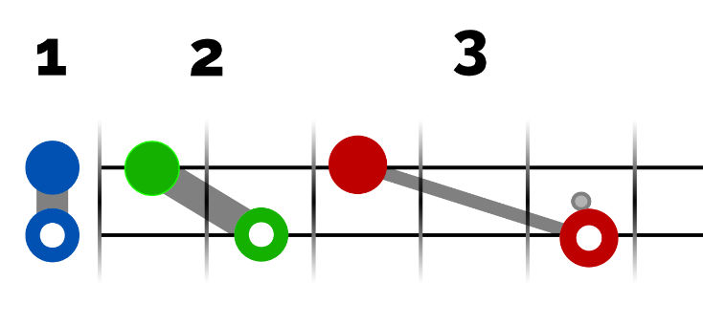

Where The Shapes Live
Now that’s fine, but it’s useful to know which shapes go on what string pairs. It’s super easy. There are only three adjacent string pairs and two of them are the same interval apart so they use the same shapes.
For the two outside string pairs – G & C and E & A – you use shapes 2 and 3.
For the inside string pair – C & E – you use shapes 1 and 2.
Easy. That means you won’t ever use shape 1 on the two outside string pairs and you won’t ever use shape 3 on the inside string pair. Assuming, that is, you’re sticking with 3rd intervals only. Other interval distances can and do use these shapes.
This means if you were to play a C major scale on the middle pair of strings, you’d use… Playing the C and E string
shape 1, shape 2, shape 2, shape 1, shape 1, shape 2, shape 2, shape 1
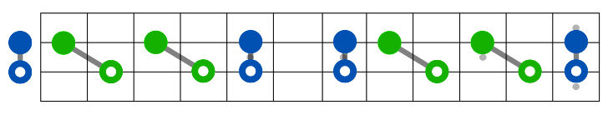
Same goes for the two outside pairs of strings. The pattern is the same, just the shapes are shifted up one number.
shape 2, shape 3, shape 3, shape 2, shape 2, shape 3, shape 3, shape 2

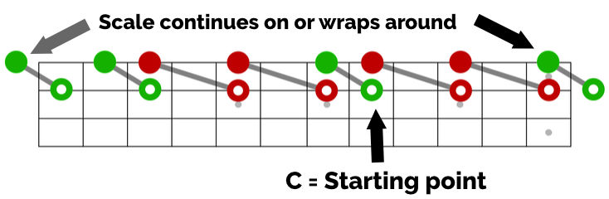

Bonus for low-G players: See if you can figure out the C scale on the two top strings. It will follow the same pattern started on the 4th fret.
4 5 7 9 10
5 7 9 10 12

lso changing the color is which note in the interval is used as the melody. For instance, I can harmonize Twinkle, Twinkle Little Star in 3rds in the key of F with the melody as the highest note, like this (melody in bold):
A |--------3--3--5--5--3-----1--1--0--0-----------|
E |--1--1--5--5--6--6--5-----3--3--1--1--3--3--1--|
C |--0--0--------------------------------4--4--0--|
G |-----------------------------------------------|
But I could also make the melody the lower note in the interval and get a completely different sound. Like this:
A |--0--0--8--8--8--8--8-----5--5--3--3--1--1--0--|
E |--1--1--8--8--10-10-8-----6--6--5--5--3--3--1--|
C |-----------------------------------------------|
G |-----------------------------------------------|

F scale ideas

just move the shapes around to fit the scale notes on both strings. An F major scale in 3rds would go…
A |--0--1--3--5--7--8--10-12--|
E |--1--3--5--6--8--10-12-13--|
C |---------------------------|
G |---------------------------|

continuing from there you would get a D scale in thirds:
A |---------------------------|
E |--2--3--5--7--9--10-12-14--|
C |--2--4--6--7--9--11-13-14--|
G |---------------------------|

learn, the middle set is a hand breaker so I won’t include it:
A |--7--Or-----8-----------------------|
E |--3--this:--5--AND...---------------|
C |-----------------------7--Or-----8--|
G |-----------------------3--this:--5--|

An A minor scale in 4ths on the bottom two strings would go like:
A |--0--2--3--5--7--8--10-12--|
E |--0--1--3--5--7--8--10-12--|
C |---------------------------|
G |---------------------------|

Get this under your fingers. F is on down A starts 2 4
Here is a G scale in 10ths:
A |--2--3--5--7--9--10-12-14--|
E |---------------------------|
C |---------------------------|
G |--0--2--4--5--7--9--11-12--|

